FROM: The Cathedral of St. John the Divine

CONTACT: Rubenstein
Julie Falvo – (212) 843-9341 / jfalvo@rubenstein.com ______________________________________________________________________________
CALENDAR LISTING

YOUNG SINGERS FROM AROUND THE EPISCOPAL DIOCESE OF NEW YORK
CONVENE AT THE CATHEDRAL OF ST. JOHN THE DIVINE
FOR THE 2023 DIOCESAN CHORISTER FESTIVAL

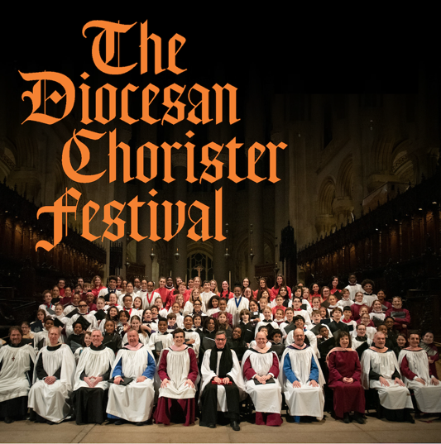

Music lovers take note! Over 100 young singers from throughout the Episcopal Diocese of New York and the NYC region will come together for the Diocesan Chorister Festival on January 28, 2023 from 9:00 AM to 4:00 PM at the Cathedral of Saint John the Divine, 1047 Amsterdam Avenue (at 112th Street) in Manhattan.

The day of music will culminate in a 4:00 PM service of Choral Evensong in the Cathedral, featuring the wonderful music of the combined choirs led by Bryan Zaros, the Cathedral’s Associate Director of Music and Choirmaster, and Mary Huff, Artistic Director at New York City Children's Chorus.

Attendance to the Evensong service is free, and no tickets are required.

For more information, please visit: https://www.stjohndivine.org/calendar/44699/chorister-festival-evensong

EVENT: Diocesan Chorister Festival

DATE: January 28, 2023

TIME: 9:00 AM to 4:00 PM Festival
4:00 PM Choral Evensong

LOCATION: The Cathedral of Saint John the Divine
1047 Amsterdam Avenue (at 112th Street)
Manhattan

###

