RELEASE
For further information please call

Julie Falvo, Rubenstein Communications
(212) 843-9341 / jfalvo@rubenstein.com

Isadora Wilkenfeld, Cathedral of St. John the Divine
(212) 316-7468 / iwilkenfeld@stjohndivine.org

THE CATHEDRAL OF ST. JOHN THE DIVINE
ERECTS OFRENDAS IN OBSERVANCE OF EL DÍA DE MUERTOS
AND IN MEMORY OF VICTIMS OF GUN VIOLENCE

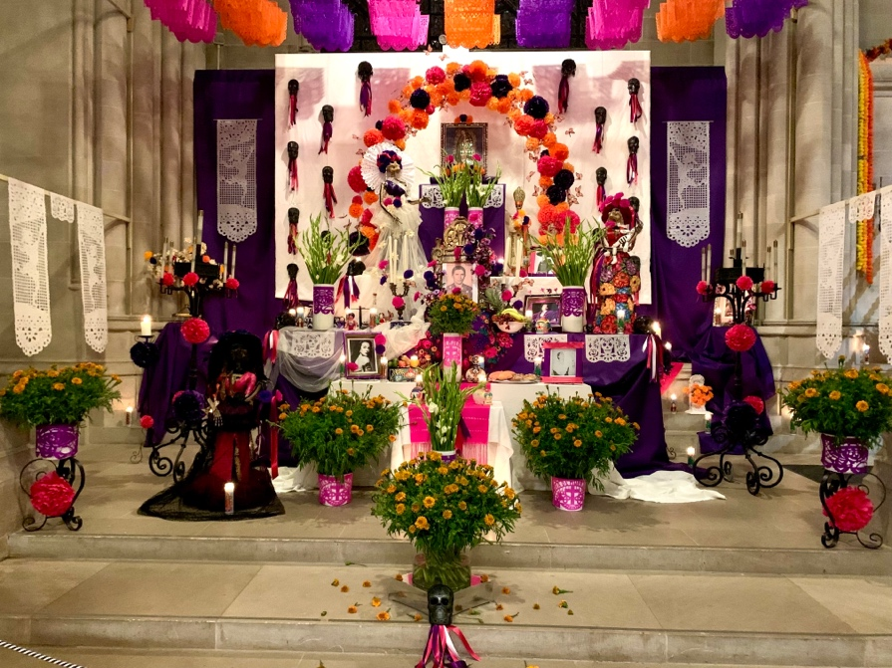

***
The Cathedral of St. John the Divine, in collaboration with artist Sebastián Gámez, will erect altars, or ofrendas, for el Día de Muertos, the Mexican Day of the Dead, culminating in a service for the Feast of All Souls on Thursday, November 2 at 7:30 PM at the Cathedral of St. John the Divine, 1047 Amsterdam Avenue (at 112th Street).

El Día de Muertos, or Day of the Dead, is the traditional Mexican and Indigenous American holiday that honors the memory of departed family, loved ones, and ancestors. The culturally-rich celebration can be traced back to the time of the Aztecs, 3,000 years ago. For the third year in a row, artist Sebastián Gámez will create ofrendas within the Cathedral’s soaring Gothic interior, uniting Latin American tradition with the Cathedral’s Anglican roots.

Mexican-American, New York-based designer and artist Sebastián Gámez, who conceived and created the two Día de Muertos ofrendas, has collaborated with the Cathedral since 2021 on these installations, which combine art and devotional imagery. The ofrendas will be constructed throughout October. On November 2, the Cathedral will observe a service of Choral Evensong framed by movements of the Fauré Requiem and including music by Amy Beach, Florence Price, Jean Sibelius, Samuel Barber and chant. The Very Reverend Patrick Malloy, Dean of the Cathedral, will preach, and the names of departed loved ones will be read aloud in mourning and commemoration, providing a sacred space for congregants and visitors to pay tribute to their beloved dead, the power of art, and the fragility of human life.

The ofrendas will be traditionally adorned with cempasúchil (marigolds), calaveras (skulls), calacas (skeletons) and catrinas (richly dressed skeletons). Alongside these symbols of the beauty and fragility of human life, the altars will contain photos and mementos of those who have died. In addition, this year’s ofrendas will have a special focus on the impact of gun violence across the United States. So far this year, there have been over 500 mass shootings in the U.S, and targeted shootings are on the rise, disproportionately impacting certain marginalized groups.

Visitors are invited to bring photographs or mementos of their departed loved ones to place on the ofrendas through the end of November. For more info on the Cathedral’s November 2 All Souls service and other upcoming gatherings, visit stjohndivine.org.

About The Cathedral
Over one hundred years ago, the trustees of the Cathedral Church of Saint John the Divine conceived its mission to be a house of prayer for all people, an instrument of church unity, and a center of intellectual light and leading in the spirit of Jesus Christ.

Today, as the mother church of the Episcopal Diocese of New York and the seat of its bishop, the Cathedral Church of Saint John the Divine serves the many diverse people of our diocese, city, nation, and world through the worship of God; pastoral, educational and community outreach activities; cultural and civic events; international ecumenical initiatives; and the preservation of the great architectural and historic site that is its legacy.

###

